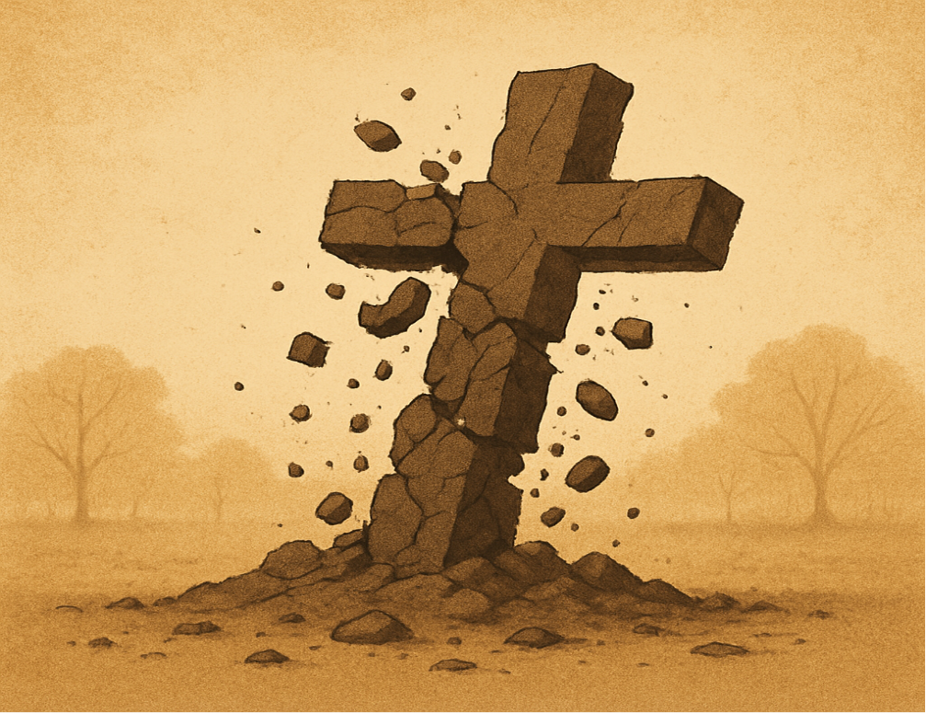

The Making and Unmaking of a Christian Zealot
A Minister’s Journey Out of Christianity
By Dale W. O’Neal, Ph.D.

I was almost 30 when I began to suspect the core of my Christian faith–salvation requires a human sacrifice—was an invention of humans, not God. Like so many Christians, particularly those born into the faith, I had given little thought to the gruesome physical and emotional reality a human sacrifice entailed: raw terror for victim, executioner and observer. It never occurred to me to ask what kind of being—human or divine—would get so angry at someone’s disobedience, or worse, disbelief, that he would require the death of his own child to regain his favor? And, to add insult to injury, make submission to this fate a condition of the father’s love.
Yet, Jesus said this is precisely why his father loves him: “For this reason the Father loves Me, because I lay down My life . . .” (John 10:17). How could the Creator and father of all come up with such a barbaric scheme? Christian writer, C.S. Lewis found himself in the same dilemma when he came face to face with what he called “the atrocities” of the Bible’s God: “The conclusion I dread is not “‘So, there’s no God after all,’ but, ‘So, this is what God is really like. Deceive yourself no longer’” (A Grief Observed, pp. 9, 10). His solution was simple: ignore or deny the validity of biblical passages that reflected badly on “the goodness of God,” as he put it. Thomas Jefferson, a deist, did the same thing about a century earlier, when he created his Jefferson Bible by literally cutting out offending passages. However, he was not nearly as delicate as Lewis in his explanation: In an 1813 letter to John Adams, he described his task as separating the “diamonds” (Jesus moral teachings) from the “dunghill” (miracles and other supernatural accounts).
I tried the “cafeteria Christian” approach of Lewis and Jefferson for a short time, but its raw duplicity soon wore me down. The fact is, Jesus talked more about hell and condemnation than any other subject and far more than any other figure in the New Testament. That’s a lot to pretend is not there (see Dan Barker’s GOD—The Most Unpleasant Character in All Fiction, Chapter 28).
Returning to the conversation about human sacrifice, even more confounding was why so many gods came up with the same reprehensible idea. It was practiced in almost all ancient societies, even in different hemispheres. This reinforced my skepticism about the divine origin of human sacrifice. This, in turn, led me to question two other disturbing pillars of my faith, which, along with human sacrifice, I now see as the most hideous ideas ever conceived by humans: eternal punishment and genocide. All three are found in Christianity and Judaism and the last two in Islam.

My Christian education taught these practices were justified by the rebellion of humans against God. I see now in hindsight, my convictions weren’t based on critical thinking, but my identity as a Christian. However, before getting into that, some historical context will be helpful.

I attended a small Christian college in Santa Barbara (Westmont), after which I went to Talbot School of Theology in La Mirada, California where I received my Master of Divinity degree and was chosen “Preacher of the Year.” Also noteworthy is my father was dean of Talbot for many years. After seminary, I served as an associate minister for five years and also began graduate school in psychology. Eventually, I got a doctorate in psychology and became a psychologist. Shortly after leaving the church, I wrote the book “Meet the Man from Nazareth,” which was published in 1972 by Zondervan, the largest Christian publisher at the time. It was a tribute Jesus the man as presented in the New Testament. Not surprisingly, since leaving Christianity, the book has followed me everywhere I go.

My crisis of doubt began with a soul-rattling dilemma at age 28 which challenged not my Christian identity, but my identity as a human being. My wife and I were contemplating having a baby. The possibility occurred to us: what if our child failed to accept the sacrifice of Jesus as his or her own? Haunting us was that familiar verse in the Gospel of John: “He who does not believe has been judged already, because he has not believed in the name of the only begotten Son of God” (John 3:18). We realized bringing a child into the world would place him or her at risk of eternal punishment for the “sin” of being born—a matter in which he or she would have no say. How could we do that, or for that matter, how could any Christian couple put their child in such jeopardy? After all, there are countless examples of children of devout Christian parents who don’t become Christians, or worse yet, leave the faith (as was the case in my family).

“Hell is truth seen too late”—Thomas Hobbes, 1651

I can’t imagine there being a more devout Christian woman than my mother. She was an exemplar of kindness, compassion and service to her family, church and community. She led Bible study groups into her nineties and regularly visited “the elderly” who often were much younger than she. She got up in the wee hours every morning to read her Bible and mostly pray. She would pray for hours and never doubt its efficacy. If the Lord was slow to answer, she would pray harder. There was never any doubt about what she pleaded with the Lord the most: that her children who left the faith would “return to the Lord.”

Fast forward to the weeks of decline before she passed. A host of dear church friends came to visit her and pray together. They would ask what she would like them to pray for and invariably it would be “Oh please pray that my children will come back to the Lord.”

In these final days of her life, in the most personal way, she came face to face with the horrific catastrophe at the heart of her faith. It was a tragedy for her and her children on an infinite scale. For her children it meant an eternity of suffering (“weeping and gnashing of teeth,” as the Gospel of Matthew puts it). For her, however, it also meant an eternity of “weeping and gnashing of teeth” as she forever contemplated the suffering of her children, and for that matter, most of God’s children. Without divine intervention, there is no way she could enjoy the “mansions” of heaven (as John 14 puts it).

To make it possible for the faithful to enjoy heaven while most of their fellow humans endure unrelenting suffering, two possible divine interventions come to mind. The first is heavenly amnesia: God simply blots out the memory of past dear ones and any awareness of their disastrous fate. The second is more sinister and incomprehensible. As the Creator and Intelligent Designer of the cosmos, God explains to those in heaven how designing a world in which this outcome is possible, even probable, makes moral sense. And, his justification would have to be so convincing that intelligent, loving and compassionate people like my mother would buy it. Compared to this, justifying the Holocaust would be child’s play.

The tragedy of my mother’s death is that rather than passing with the satisfaction of a life well lived, her last days were hell: truth seen too late. Not surprisingly, even in this darkest moment of the soul, she never doubted, her faith never wavered. She just prayed harder.

How I Became a Christian Zealot
So back to the slippery slope that led me to question the divine origin of my faith. To begin, I want to comment on how one’s identity reinforces one’s beliefs. To help with this, I will put on my psychologist’s hat to explain the interplay between two parts of the brain. Critical thinking is done by the frontal cortex—the last part of the brain to develop. One’s identity is bound primarily to the amygdala—one of the first parts of the brain to develop. The job of the amygdala is to ensure one’s physical and emotional survival of which one’s identity is a major part.

When one’s identity is threatened (ego, gender, family, race, caste, religion, political affiliation, etc.), the amygdala signals the adrenal glands to secrete adrenaline into the blood stream. This causes a state of high alert where body and mind are focused on escape by fight or flight. To aid in this escape, the adrenaline impedes or even blocks access to the frontal cortex; it wants the threatened person to react, not think. Rarely, however, does the adrenaline block the frontal cortex completely. So when one’s belief system is threatened, the amygdala maintains enough of a connection with the frontal cortex to marshal a host of “answers” which satisfy True Believers, but rarely anyone else. One “answer” in particular serves as a final barrier protecting one’s identity: the subjective authentication of one’s faith: one knows his/her faith is true because it feels true. When combined with other “answers,” this “answer” becomes a protective shield no rational argument can penetrate.
The Subjective Authentication of One’s Faith

Importantly, whether the path to faith is by imprinting or grafting, virtually all religions claim a subjective experience which authenticates the truth of their faith. So, the ultimate assurance of the truth of one’s faith comes from feeling it is true: “I just know in my heart it is true.” “Critical thinking” then confirms what the heart already knows. In his classic book, “The Varieties of Religious Experience,” William James observed conversion experiences are essentially identical in all religions. Of course, they all can’t be true.

Christians are told, “The Spirit himself bears witness with our spirit that we are children of God” (Romans 8:16). A thousand times over I have belted out the gospel hymn He Lives: “You ask me how I know He lives; He lives within my heart.” Well-known Christian scholar, William Craig, asserts “the way we know Christianity to be true is by the self-authenticating witness of God’s Holy Spirit.” He goes so far as to claim this experience is so “immediate” and “unmistakable” that it rises to the level of “objective knowledge.” Craig explains: “I mean that the experience of the Holy Spirit is veridical [truthful, trustworthy— my ital.] and unmistakable . . . for him who has it; that such a person does not need supplementary arguments of evidence in order to know and to know with confidence that he is in fact experiencing the Spirit of God; that such experience . . . is the immediate experiencing of God himself; . . . that such an experience provides one not only with a subjective assurance of Christianity’s truth, but with objective knowledge of that truth [my ital.]; and that arguments and evidence incompatible with that truth are overwhelmed by the experience of the Holy Spirit for him who attends fully to it.” It goes without saying that the faithful of other religions claim the same thing.

As mentioned above, knowing one’s faith is true because it feels true is the final protective barrier insulating the faithful from challenges to their core identity (in fact, rarely do the faithful admit any doubt whatsoever). The point is that for the vast majority, faith is far more a matter of identity reinforced by culture, feelings, and specious “answers” (in that order) than a decision arrived at by critical thinking. This is why intellectual arguments against someone’s religion are rarely productive. To paraphrase the words of Anglo-Irish satirist, Jonathan Swift, “You can’t reason people out of something they weren’t reasoned into in the first place.” What intellectual argument can compete with “I am a Muslim/Hindu/Jew/Christian,” or, “I just know in my heart it is true”?

I know, because I was a poster child for “I am a Christian and I just know it’s true.” My former certainty is humbling and sobering. The words of Charles Darwin in The Descent of Man ring true: “Ignorance more frequently begets confidence that does knowledge.” More recently, Nobel Prize recipient, Daniel Kahneman, in his book, Thinking, Fast and Slow, lamented “our almost unlimited ability to ignore our ignorance” (p. 201). Sadly, I identify with the words of psychologist and former evangelical, Valerie Tarico, “I know how wrong can feel so right.”

Imprinting

Like most Christians, I wasn’t a born-again Christian, I was born Christian. My “faith” was no leap in the face of doubt because I never doubted. So, for me, believing was easy. In fact, I don’t remember ever not believing. My faith was an identity I was born with. It distinguished me from Jews, Muslims, Hindus and even Roman Catholics. A Christian was simply who I was.

Faith by birth is the primary path to faith for most “people of faith” because of a powerful psychological force known as imprinting: newborns pattern their behavior and thinking after those around them. Richard Dawkins put it succinctly: “How thoughtful of God to arrange matters so that, wherever you happen to be born, the local religion always turns out to be the true one.” This is reminiscent of a classic definition of a cult: someone else’s religion.

Although most are imprinted into their faith by birth, some are grafted in by conversion. Most converts are not converted into a faith because they find evidence for its truth compelling. Far more often they report experiencing a divine presence enter them which fills them with new power, clarity and purpose. In Christianity, this commonly is referred to as being “born again.” And, just as in actual childbirth, the bonding hormone, oxytocin, is released binding new believers to their new faith.

Groupthink

Once faith and identity are fused, this fusion typically is reinforced by a social phenomenon known as groupthink. Groupthink is a toxic byproduct of the desire for people to associate with others who are like themselves: “Birds of a feather, flock together.” With groupthink, dissent is discouraged in favor of conformity; alternative viewpoints are suppressed and frequently the group isolates itself from outside influences. Typically, group members are more concerned about group acceptance and cohesion than critical thinking, so reservations go unexpressed. The result is unanimous, but often flawed decisions (The decision to invade Cuba by the Kennedy administration is a prime example). The power of groupthink was captured poignantly over two hundred years ago by Thomas Paine in his introduction to “Common Sense”: “The long habit of not thinking a thing wrong gives it the superficial appearance of being right. Time makes more converts than reason.”

Like inbreeding, group think thrives in isolation. In my case, I was the son of a minister in the Grace Brethren Church, an evangelical denomination whose motto is “The Bible, the whole Bible, and nothing but the Bible.” This translated socially into “Christians, only Christians, and nothing but Christians.” “Christian” was simply who you are, which included its core beliefs. In booming voices, my father and myriad preachers and teachers assured the flock that the God of the Bible was in complete control; they were saved and Jesus soon would return to take them to be with him forever. As faithful servants in waiting, our primary task was to warn as many folks as possible of their impending doom if they failed to accept Jesus as their savior before it was too late. “Too late” meant (1) before they died (which we cautioned could be sudden), or (2) before Jesus returned (which also could be sudden: “the day of the Lord will come like a thief in the night”—I Thessalonians 5:2). Not surprisingly, for most of my childhood I planned to be a missionary. “Saving souls” before it was too late was serious business!

Gaslighting

A critical component of groupthink is creating doubt in one’s rationality, or gaslighting. Gaslighting is a form of psychological manipulation that seeks to make people doubt their intelligence, memory, perception and sanity. It seeks to undermine trust in one’s own mind and instead rely on the judgement of someone else, usually an authority figure who seeks to control the individual or group.

The Bible is filled with assaults on reason which is a frequent refuge for preachers and teachers when reason and faith conflict. A favorite gaslighting passage is: “Trust in the Lord with all your heart; and lean not to your own understanding” (Proverbs 3:5). The gaslighting prize, however, goes to Isaiah 55:8,9: “For my thoughts are not your thoughts, neither are your ways my ways, ‘declares the Lord.’ For as the heavens are higher than the earth, so are my ways higher than your ways, and my thoughts than your thoughts.”

In the New Testament, Jesus is quoted as saying: “Thou didst hide these things from the wise and intelligent and didst reveal them to babes” (Luke 10:21). The Apostle Paul expands on this theme in his first letter to the Corinthians: “The message of the cross is foolishness to those who are perishing, but to us who are being saved it is the power of God. For it is written: ‘I will destroy the wisdom of the wise; the intelligence of the intelligent I will frustrate.’
Where is the wise man?
Where is the scholar?
Where is the philosopher of this age?
Has not God made foolish the wisdom of the world?
For the foolishness of God is wiser than man’s wisdom” (I Cor.1:18-25).

Finally, using the Christian scholar’s last resort, Paul gaslights Roman Christians who would dare question the justice of God: “Who are you, O man, who answers back to God? The thing molded will not say to the molder, ‘why did you make me like this,’ will it” (Romans 9:20)?

The objective of Paul’s gaslighting was to generate sufficient mistrust in his readers’ rationality so they would consider a possibility that they otherwise would have considered foolish; namely, that Jesus’ death on the cross [a human sacrifice] is essential for their salvation. Using gaslighting, Paul sought to seduce the Corinthians into believing the message of the cross only appears foolish. In actuality, it is the wisdom of God masquerading as foolishness. So, at least according to Paul, those able to accept this are not fools at all, but the super-wise who possess the very power and wisdom of God. On the contrary, those shackled by their intelligence, the wisdom of the wise, scholars and philosophers are the real fools since they cannot accept the foolishness of the cross.

These fools who cling to their rationality are doomed to perish. However, those fortunate former fools able to accept the foolishness of the cross will be granted eternal life. In Paul’s world, foolishness is transformed into a virtue and the call goes out to the Corinthians and all future believers to become “fools for Christ.” This call was famously reprised by the late Supreme Court Justice Antonin Scalia in a speech at a prayer breakfast for the First Baptist Church of Jackson, Mississippi where he exhorted listeners, “We are to be fools for Christ.”

Gaslighting 2.0

If gaslighting 1.0 has been effective, gaslighting 2.0 is usually close behind. With critical thinking neutered, now a believer is asked to embrace notions demonstrably false: the Bible has no contradictions; the resurrection accounts are consistent; Jesus was correct when he promised he would return “before this generation passes away”; core components of Christianity were not borrowed from earlier religions. Similarly, believers are expected to justify actions most would find morally repugnant: the universal flood, the God-sanctioned genocides of Joshua to take the Promised Land from the Canaanites; the murders of the firstborn of the Egyptians; the demand for a human sacrifice to assuage the anger of the Creator toward his children; the consequence of eternal punishment or annihilation for those who do not accept Jesus as their savior; the preselection by God of those who will and will not believe; condoning slavery and the subjugation of women.

Another striking example of gaslighting 2.0 is the attempt—discussed above--to convince Christians their subjective experience of the Holy Spirit is so overwhelming it rises to the level of objective truth. William Craig opines “it is the self-authenticating work of the Holy spirit that supplies knowledge of Christianity’s truth.” Craig explains in incomprehensible gibberish why Christians are immune to evidence against the truth of Christianity: “Because [Christian] belief is formed in response to the self-disclosure of God himself, who needs no external authentication, it is not merely rational for us but constitutes knowledge. We can be confident of Christianity’s truth.”

Gaslighting 3.0

Gaslighting 3.0 is the most disturbing and dangerous stage of all. This occurs when believers are so certain of their convictions, they condone, justify and even commit acts of violence in service of them. Here the words of Voltaire (1694-1778) and Pascal (1623-1662) are chillingly prescient: “Those who can make you believe absurdities can make you commit atrocities” (Voltaire); “Men never do evil so completely and cheerfully as when they do it from religious conviction” (Often attributed to Pascal).

History is littered not only with the carnage of holy wars with both sides certain God was on its side, but also with the detritus of what FDR called “racial arrogancies.” This is the seductive and pervasive human tendency—despite overwhelming scientific evidence we are 99.9% genetically identical--to be certain one’s particular race, nation, religion, family, tribe, caste, even school, is superior. The result is group members exalt their own group and diminish, dehumanize, demonize, dominate, even eliminate, birds of another feather.

Confirmation Bias

Another powerful component of group think is confirmation bias. This mental pattern was first identified by psychologist Leon Festinger in 1957, which he labeled cognitive dissonance. Festinger found that when most people are confronted with evidence that contradicts their convictions, instead of modifying their beliefs or holding them less strongly, rather than facing the pain of admitting they are wrong, they double down. And the more they have invested in the false beliefs, the more they will respond to contrary evidence by intensifying their attachment to those untrue notions. Economist, John Kenneth Galbraith put it succinctly: “Faced with having to change our views or prove that there is no need to do so; most get busy on the proof.”

When one’s entire social network doubles down on a threat to one’s faith, it is a formidable reinforcement of the faith and a major disincentive to doubt or dissent. This is where the desensitization process kicks in and the faithful begin to tolerate specious explanations, habituate to the demand for a human sacrifice, and even eternal punishment doesn’t bother that much anymore. In the world of double-downs, poor explanations are sufficient, and gross immoralities are diminished, ignored or even valorized as the end justifies the means. What follows are several popular double-downs.

Selective Attribution: Counting the hits and ignoring the misses

Answered and unanswered prayer is an excellent example of selective attribution. When one gets what one prayed for it is “God answered my prayer.” When one doesn’t, it is “God answered my prayer, and the answer was ‘no’; or “I need to pray harder or more’; or “I didn’t pray according to God’s will.” Similarly, God gets credit for healing the cancer patient, but not for causing the cancer in the first place. And when the cancer patient dies, “It was God’s will and God called him home.”

Another common form of selective attribution, related to prayer, is the claim that God spoke to a person. This “speaking”—rarely claimed to be audible--is generally framed as “God led me” or “the Lord spoke to me” or “I felt the clear leading of the Spirit.” Then, when God doesn’t provide the funds for the Spirit-inspired vision, “God leads” in a different direction. Selective attribution is a pervasive biblical theme in the story of the children of Israel: when good things happen, God is praised; when bad things happen, the people are blamed: “If my people who are called by my name humble themselves and pray, and seek My face and turn from their wicked ways, then I will hear from heaven, will forgive their sin, and will heal their land” (II Chron. 7:14).
Praise believers and demean unbelievers

To bolster confidence in the credibility and reasonableness of their beliefs, Christians offer a host of reasons for unbelief to divert attention from the most common and most threatening one: unbelievers don’t find the evidence compelling. As mentioned above, stubbornness is the most common attack on unbelievers. To bolster this assertion of the unbeliever’s belligerence, Christians are fond of combining John 7:17 (unbelievers are stubborn) with John 6:44 and John 12:32: “No one can come to me unless the Father who sent me draws him,” and “If I be lifted up, I will draw all men to myself.” By spinning these verses to mean God draws everyone to come to Jesus (which is demonstrably false); every unbeliever becomes a rebel against God and every believer an ally. Professor Craig knows “the unbeliever who is truly seeking God will be convinced of the truth of the Christian message.” To anyone who doesn’t find the evidence for Christianity compelling, Dr. Craig knows that person not only is not truly seeking God, but “he’s throwing up an intellectual smoke screen to keep from confronting the real issue: his sin before God,” and later “it may only mean that many people are close-minded.” If devotees of other religions are surprised to hear they have rejected the drawing of the Holy Spirit, they will be apoplectic when they learn they are close-minded, sinful rebels against God.

To add insult to injury, not only is unbelief the result of stubbornness, it also is the result of spiritual weakness: they have been blinded and deceived by the devil: “the god of this world has blinded the minds of the unbelieving” (II Cor. 4:4). In contrast, believers are viewed as spiritually strong enough to resist the wiles of Satan.

Although rarely mentioned by believers—it’s cruelty and blatant unfairness is inexplicable and embarrassing--a final reason for unbelief is God preselects who will and will not believe: “You do not believe, because you are not of my sheep. My sheep hear my voice, and they follow me; and I give eternal life to them; and they shall never perish” (John 10:26-28). To make matters worse, the apostle Paul says God sends to unbelievers “a deluding influence so that they might believe what is false, in order that they all may be judged who did not believe the truth but took pleasure in wickedness” (II Thess. 2:11, 12). If someone protests this is not fair, elsewhere Paul retorts: “So then he has mercy on whom he desires, and he hardens whom he desires” (Romans 9:18). If the questioner persists, Paul scolds: “Who are you, O man, who answers back to God: The thing molded will not say to the molder, “Why did you make me like this,” will it?” (Romans 9:20). The bottom line is unbelievers are the unlucky “vessels of wrath prepared for destruction” and believers are the lucky “vessels of mercy, which He prepared beforehand for glory” (Romans 9: 22, 23).
Learning “Answers”

An essential task for all True Believers is to learn how to counter every objection a non-believer might raise about the faith. The Bible admonishes: “Always be prepared to give an answer to everyone who asks you to give the reason for the hope that is in you” (I Peter 3:15). If you were really serious about your faith—as surely I was—you go to seminary to master these “answers.” In fact, to receive one’s degree at many Christian schools of higher education, like mine, students are required to sign a statement of faith and a laundry list of approved doctrines as a prerequisite to graduate.

As a minister, you are God’s messenger, and certainty is your currency. People don’t want fuzzy calls to do good, they want “Thus, saith the Lord.” After all, it is the Ten Commandments, not the Ten Suggestions. The call to certainty is championed in one of the most unsettling and divisive verses in the Bible: “If the trumpet gives an uncertain sound, who shall prepare himself to the battle” (I Cor. 14:8)? For ministers the takeaway from this verse can only be “When in doubt, shout.”

I say “divisive” because certainty one is right and everyone else is wrong is polarizing. It produces people of belief, not people of faith. Faith, by definition, contains a measure of uncertainty--a dash of doubt seasons faith. I agree with the Psalm that says, “The fool says there is no God” (Psalm 14:1). However, I would add, “Another fool says there is a God,” but “The wise person says there may be a God and there may not be a God,” or “There may be a God, and it may be someone else’s.”

The rupture in the human family will not be healed by people of belief, but people of faith who respect and seek to learn from people of other faiths and no faith. People of faith (atheists and agnostics included) appreciate the uncertainty at the heart of the human experience—that if there is an intelligent designer, uncertainty is at the core of the design. These three maxims capture this design succinctly:
1. Absolute truth may exist; and you may even possess it; but you cannot know that absolutely.
2. God may exist; and he or she may even be yours; but you cannot know that absolutely.
3. Absence of evidence is not necessarily evidence of absence, but absence of certainty
Believing is Easy … Disbelieving is Hard Work
The parental dilemma at age 28 launched me into a mind and soul-searching journey where I had to traverse all the land mines mentioned above. Yes, disbelieving was hard work, but before long that hard work turned into an exhilarating ride to liberation. William James described this journey as a counter-conversion: the transformative experience of being converted away from something, rather than to something.
As a result of my counter conversion, my wife and I were able to celebrate the birth of our daughter free of stress about her eternal wellbeing. However, my crisis of faith left me even more curious about what compelled humans to practice human sacrifice in the first place. This launched a quest that took me back 20,000 years to a time when people worshipped the Moon Goddess who died and resurrected each month. These Stone Age ancestors were convinced that by consuming her magical moon blood and imitating her death they too could be resurrected and attain immortality. So, for Goddess worshippers, human sacrifice made perfect sense.
What I discovered is their sacrificial paradigm became the template for the sacrificial paradigms of Judaism and Christianity. This remarkable mythmaking story is told in my 2025 book The Ancient Moon Goddess—Crushed by Patriarchy, Buried by Judaism, Hidden in Christianity: https://a.co/d/eL3pZZd.
For now, I will share the image of the Sumerian Tree of Life (ca. 2500 BCE) that is my picture worth a thousand words. It was found on a cylinder seal predating the Genesis Garden of Eden story by at least a thousand years. It broke through my wall of confirmation bias and made me realize the Genesis story almost certainly was borrowed from the Sumerians by Hebrew scribes. They changed it from an offering of knowledge and immortality from the fruit of the Tree of Life into a temptation story demonizing the Goddess and her primary animal representation, the serpent.
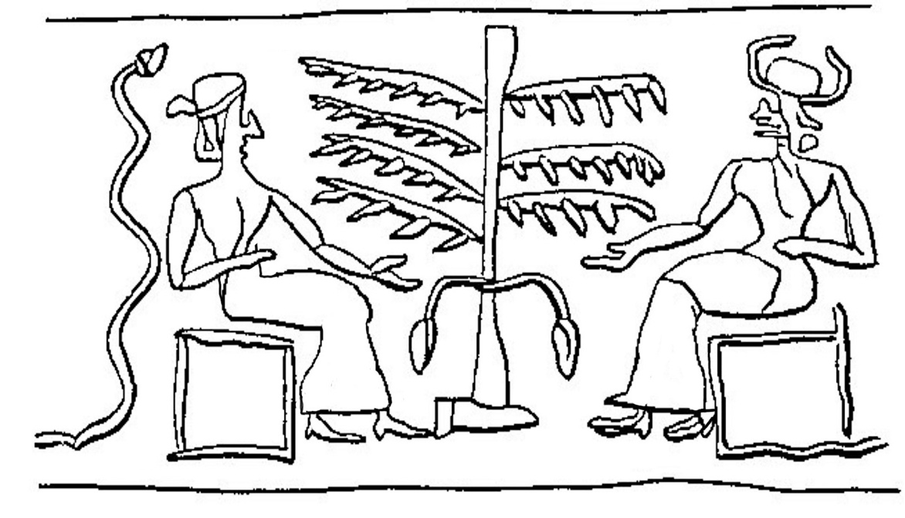
Source: The Sumerian Tree of Life, The Mythic Image, Joseph Campbell, p.295
Why I Am Sharing My Journey Now

After leaving my tribe some fifty years ago, I decided to report back to whomever cares to listen. I now see all seekers as mountain climbers following different paths to the summit; and as we get closer to the top, the pathways merge. Good climbers share what they have discovered on the way (which I am doing in this essay). As Huston Smith notes in The Religions of Man, most will follow a path taken from one’s own culture. However, in a sobering reminder of my earlier life as a zealot, he cautions: “Those who circle the mountain trying to bring others around to their paths are not climbing.”

For many years I have been exploring various faith and no faith traditions to inform the how and why of my life. I call it Revelation by Resonation: what resonates with my mind and heart guides me to the summit. I have learned to hold my faith softly recognizing that a dash of doubt seasons faith and that an element of doubt is inherent in the very idea of faith.

In that spirit, I describe myself as an Agnostic of Faith. Agnostics of Faith remain firm in their uncertainty but take a leap of faith that there is a higher power. Agnostics of Faith don’t believe this. Rather, they view it as their best guess; and this faith informs how they view their past, present and future.

Agnostics of Faith are people of faith in the fullest sense of the word, whether their higher power is aligned with a faith tradition or not. Their faith allows them to live in a friendly universe though they are unsure what it is. For many it accommodates faith in an afterlife, though they can’t know this for sure either. However, they are comforted in knowing that if they are wrong, they will never know it because they will be dead. In the meantime, they will have lived a happier life in the illusion.

I will close with a paraphrase of Rabbi Abraham Heschel:
We are partners in the drama of continuous creation, and by whatever we do, we either advance or obstruct that grand purpose which binds the human family in a common cause.
I hope this essay boosts your climb to the summit and encourages your contribution to our mutual exploration of the great wonder of existence.

Bibliography:

Barker, Dan, 2016, GOD, The Most Unpleasant Character In All Fiction, Sterling Publishing.

Campbell, Joseph, 1974, The Mythic Image, Princeton University Press.

Craig, William Lane. 1984. Reasonable Faith. Wheaton: Crossway Books.

Daniel Kahneman, 2011, Thinking, Fast and Slow, Farrar, Straus and Giroux.
Smith, Huston. 1984. The Religions of Man. New York: Harper and Row.

The Ancient Moon Goddess—Crushed by Patriarchy, Buried by Judaism, Hidden in Christianity by Dale O’Neal and Arthur Waters was published in September 2025. It is available on Amazon https://a.co/d/eL3pZZd. His website: https://www.daleoneal.com/.

Follow him on his social media platforms.
Instagram: https://www.instagram.com/daleonealauthor/
TwitterX: https://x.com/DaleOnealAuthor
Threads: https://www.threads.com/@daleonealauthor
BlueSky: https://bsky.app/profile/daleonealauthor.bsky.social

Craig, Reasonable Faith, 31,32
Craig, Reasonable Faith, 36
Craig, Reasonable Faith, 36
Craig, Reasonable Faith, 36
Craig, Reasonable Faith, 50

